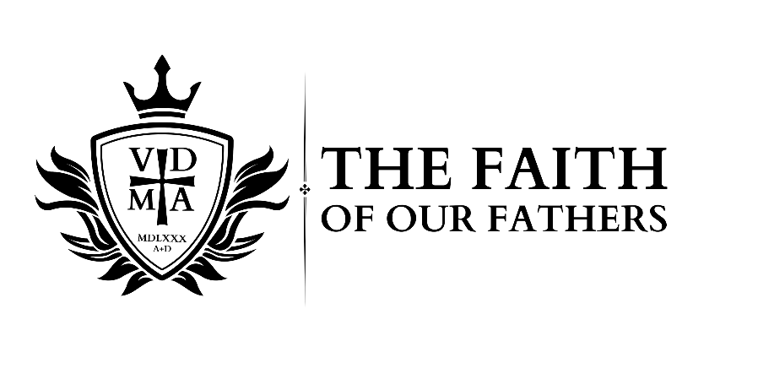

***The Gospel Shows the Father’s Grace***

The proper understanding of the Law of God is essential for a Christian. Unfortunately, there has been much disagreement in American Lutheranism concerning the role of the Law in the Church. Last year, we focused on the dangers of antinomianism, the importance of the third use of the law, and how these topics have impacted the Missouri Synod’s preaching and teaching in recent years. This year, we will be focusing on the beautiful harmony of God’s Law and Gospel and how His promises shape the Christian life. As recently sainted John Warwick Montgomery said, “The answer to antinomianism, social-gospel legalism, and existential relativism lies not only in the proper *distinction* between Law and Gospel, as C. F. W. Walther so effectively stressed, but also in the proper *harmony* of Law and Gospel, as set forth in the classic doctrine of the Third Use of the Law.”

Over two days at Good Shepherd Lutheran Church in Collinsville, IL, **February 28th and March 1st**, we will learn about and discuss God’s Law and Gospel, preaching, growth and struggle in the Christian life, and what the Lutheran Confessions have to say about all these matters.

This conference is for both laity and pastors. Come join us for good theology, fellowship, and maybe even a little fun!

**Speakers and Preachers:** Speakers: Rev. Ben Ball; Rev. Dr. Jon Bruss; Rev. Dr. Thomas Egger; Rev. Dr. Gifford Grobien; Rev. Andrew Packer; Rev. Andrew Preus; Rev. David Ramirez; Rev. Joshua Scheer Rev. William Weedon; and, Rev. Andy Wright.

Learn more and register for the conference at: <https://yourgrandfatherschurch.org/>



***The Gospel Shows the Father’s Grace***

The proper understanding of the Law of God is essential for a Christian. Unfortunately, there has been much disagreement in American Lutheranism concerning the role of the Law in the Church. Last year, we focused on the dangers of antinomianism, the importance of the third use of the law, and how these topics have impacted the Missouri Synod’s preaching and teaching in recent years. This year, we will be focusing on the beautiful harmony of God’s Law and Gospel and how His promises shape the Christian life. As recently sainted John Warwick Montgomery said, “The answer to antinomianism, social-gospel legalism, and existential relativism lies not only in the proper *distinction* between Law and Gospel, as C. F. W. Walther so effectively stressed, but also in the proper *harmony* of Law and Gospel, as set forth in the classic doctrine of the Third Use of the Law.”

Over two days at Good Shepherd Lutheran Church in Collinsville, IL, **February 28th and March 1st**, we will learn about and discuss God’s Law and Gospel, preaching, growth and struggle in the Christian life, and what the Lutheran Confessions have to say about all these matters.

This conference is for both laity and pastors. Come join us for good theology, fellowship, and maybe even a little fun!

**Speakers and Preachers:** Speakers: Rev. Ben Ball; Rev. Dr. Jon Bruss; Rev. Dr. Thomas Egger; Rev. Dr. Gifford Grobien; Rev. Andrew Packer; Rev. Andrew Preus; Rev. David Ramirez; Rev. Joshua Scheer Rev. William Weedon; and, Rev. Andy Wright.

Learn more and register for the conference at: <https://yourgrandfatherschurch.org/>